**Name – Majahar Mahamud Kazi**

**Div – B Batch – B2**

**Roll no. – 322036 PRN no. – 22110729**

**Assignment 5**

**Aim:** Write IaC using terraform to create EC2 machine on aws or azure or google cloud.

**Theory:**

1. **What is Terraform ?**

Terraform is an open-source infrastructure as code (laC) tool developed by HashiCorp. It allows developers to define and manage their infrastructure in a declarative way, using configuration files instead of manual processes.

With Terraform, infrastructure changes can be easily versioned, tested, and deployed across multiple cloud providers, such as AWS, Google Cloud Platform, and Microsoft Azure. Terraform's modular design allows for easy reuse of infrastructure code and promotes collaboration among team members. It automates the deployment of infrastructure, making it more efficient and reliable, reducing the risk of human error.

Terraform helps teams to manage their infrastructure as code, and provides greater agility and scalability to their projects.

1. **Step-by-step screenshot to install and configure Terraform:**

To download Terraform first go to link -

<https://developer.hashicorp.com/terraform/downloads> and select

required terraform version to download.

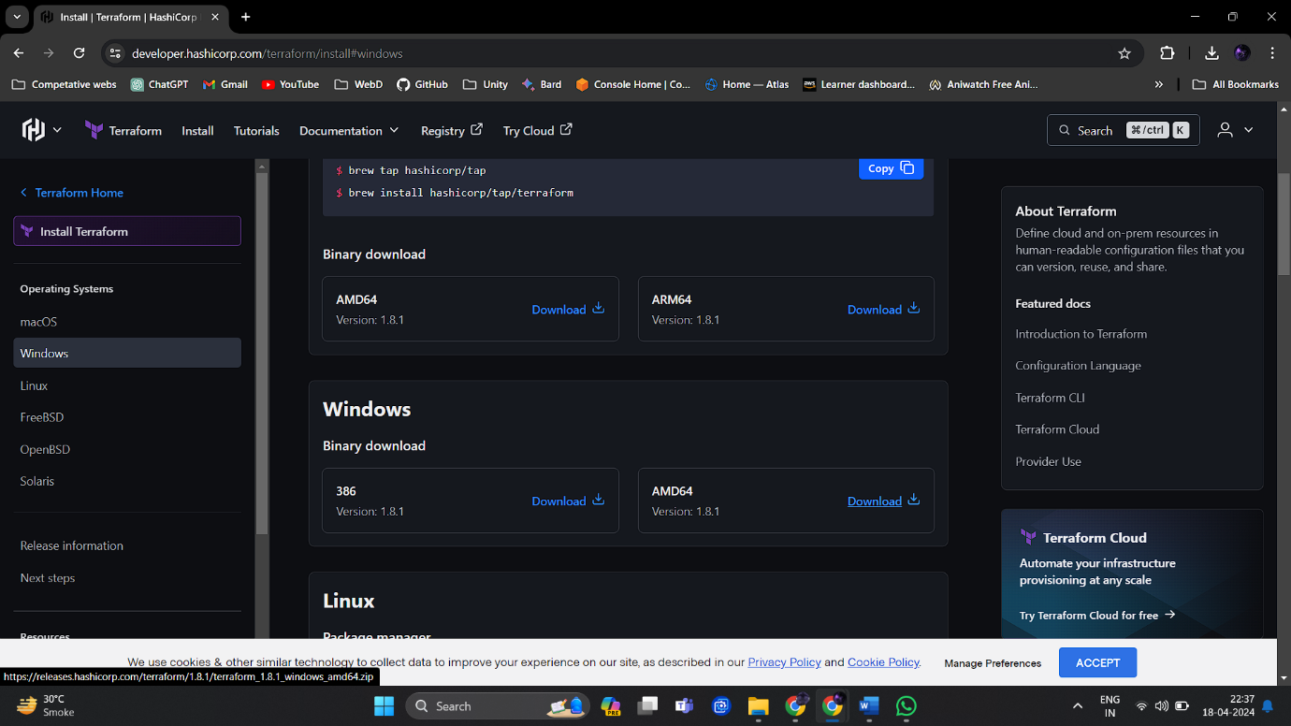

Now that we have got our terraform zip file, unzip in it your required location.

Now add the application path to system environment variables.

Check if installed.

**Terraform script to create Infrastructure on any cloud platform**

Now open VS code and create a file with name main.tf

Mention the provider. We are going to use AWS as our provider.

The region is Mumbai (ap-south-1)

The ami id of the VM is added along with other details.

Using the ‘terraform init’ command in the folder where we just created out main.tf file to initialize the Terraform Project. This will download any required plugins and initialize the working directory.

‘terraform apply’ This will create or update the resources specified in your configuration files after giving the plan.

The Instance has been deployed Successfully.

We can delete the instance using the terraform destroy. This command will destroy & delete all the instances that were created using terraform.

**USING INPUT & OUTPUT VARIABLE FILES:**

**DEFINING INPUT VARIABLES**

terraform apply -var "instance_name=Terraform_Instance"

This command will change the instance name by editing the name(It will not delete and create new instance) Terraform configurations can include variables to make your configuration more dynamic and flexible.

Query Data with Outputs: We will use output values to present useful information to the Terraform user.

**Conclusion:**

We have installed terraform and AWS CLI and learned how to use Terraform to create infrastructure as code, specifically an EC2 instance on AWS. We also learned how to use input and output variables to make our code more flexible and reusable. An EC2 Instance was deployed and also destroyed using CLI.

Author – Majahar Kazi

Thursday 18 April 2024 23:55:08 PM IST